Lab 9 Stellar Evolution

Goals
- Understand the evolution of stars and the end results of low vs high mass stars
- Become familiar with H-R diagrams and the Main Sequence
- Relate spectral type of Main Sequence stars with physical properties and lifecycle
- Use the main sequence turnoff method for H-R diagrams of 5 stellar clusters to determine their relative ages

Part 1 Stellar Evolution
After watching the video on stellar evolution you should be able to complete the following flowchart showing the lifecycle of a low mass vs. high mass star using the terms below

Main Sequence Star

Runs out of H in core

Low Mass (<8M_{sun}) High Mass (>8M_{sun})
Produces Produces

Leaving behind Leaving behind
Lower Mass Largest mass
(8-25 M_{sun}) (>25 M_{sun})

Red Giant Black Hole White Dwarf

Core Collapse Supernova Neutron Star Planetary Nebula
Part 2 HR diagrams
A diagram of the Luminosity vs. Temperature was used by Hertzsprung and Russel to display information about a large number of stars in one convenient graph. We now call these figures H-R diagrams. The HR diagram on the following page shows a small sample of stars, which you can use to answer a series of questions.

Part 3 Main Sequence Stellar properties
Complete the table below. You should be able to find information about the luminosity and temperature of stellar types from the HR diagram in this lab, or a source of your choosing (e.g. previous labs, your textbook, the internet). Calculate the lifetime directly from the equation that follows.

SPECTRAL TYPE AND PHYSICAL PROPERTIES (Mass, Luminosity, Temp, Lifetime)

 | O | B | A | F | G | K | M
Mass  [M_{sun}] | 60 | 6 | 2 | 1.5 | 1 | 0.7 | 0.2
Luminosity  [L_{sun}] |  |  |  |  | 1
Temp  [K] |  |  |  |  | 5800
Lifetime  [yr] |  |  |  |  | 1x10¹⁰

Higher mass stars burn through their fuel faster and lower mass stars burn through it slower. The lifetime on the main sequence can be approximated as

T =

Where M is the mass of the star in solar masses. For the Sun, M=1.0 and then T=10 billion years. Show a sample calculation in the space provided.

HR Diagram and Physical Properties of Stars
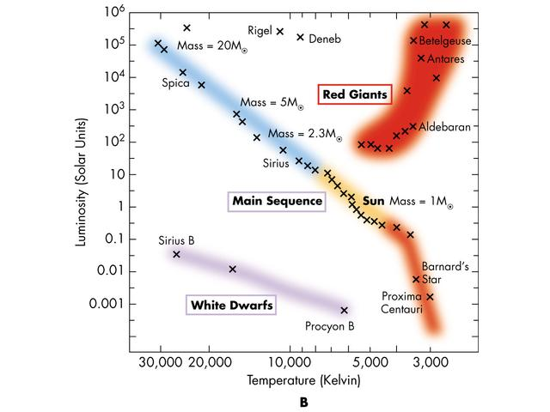
O B A F G K M
Spectral
Type Physical Properties

1 _______ Hottest main sequence stars

2 _______ Most massive main sequence stars

3 _______ Coolest main sequence stars

4 _______ Least massive main sequence stars

5 _______ Stars most like the Sun

6 _______ Types with luminosities lower than the Sun’s

7 _______ Stars with longest lifetimes

8 _______ Types with luminosities larger than the Sun's

9 _______ Stars with shortest lifetime

10 _______ Types with much higher levels of ultraviolet radiation than the Sun

Bonus: Which named stars are no longer burning hydrogen in the core?
Part 4: Cluster ages from M-S turnoff method
Use the main sequence turnoff method from the in-class presentation to rank the following clusters from youngest to oldest. Note, the variables on the axis are different than the sample HR diagram, but they serve the same function. The visual brightness on the vertical axis stands in for luminosity, and the color on the horizontal axis stands in for temperature.

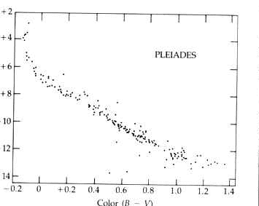
Pleiades: Open cluster

M3: Globular cluster
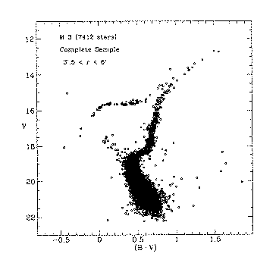

M67: Open cluster
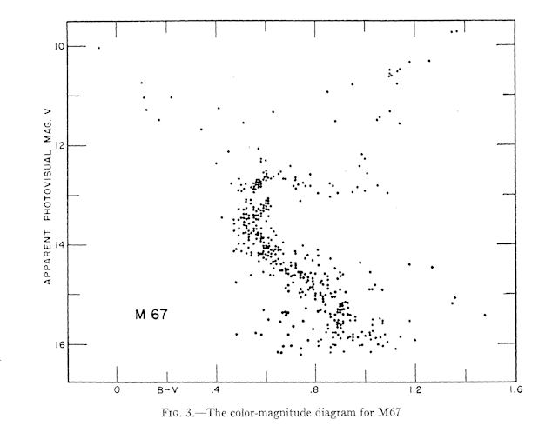

Hyades: Open cluster
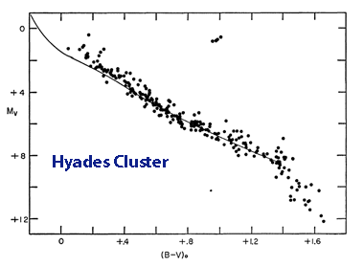

M15: Globular cluster
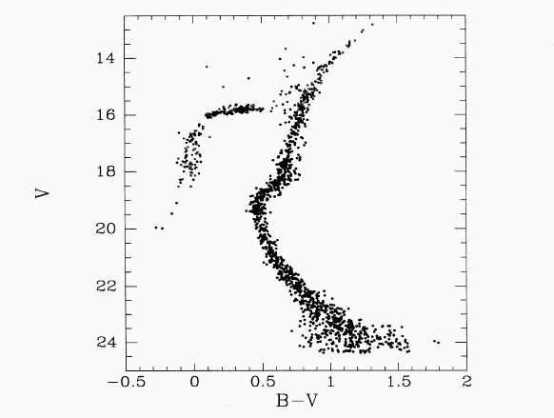

Lab Report Requirements
This report will be a summary of each of the four parts.

Part 1 – Summarize the lifecycle of a star, comparing low mass to high mass stars.
Include your completed flowchart.
Part 2 – Summarize what an HR diagram is and what the main sequence represents.
Include your responses to the HR diagram activity.
Part 3 – Summarize the physical properties of stars on the main sequence (mass, luminosity,
temperature and lifetime). Include your completed data chart from this section.
Part 4 – Summarize the Main Sequence turnoff method, and use it to rank the star clusters from
youngest to oldest.

